🌾 TaiStat AgroLink – Final App Flow (with Business Model)
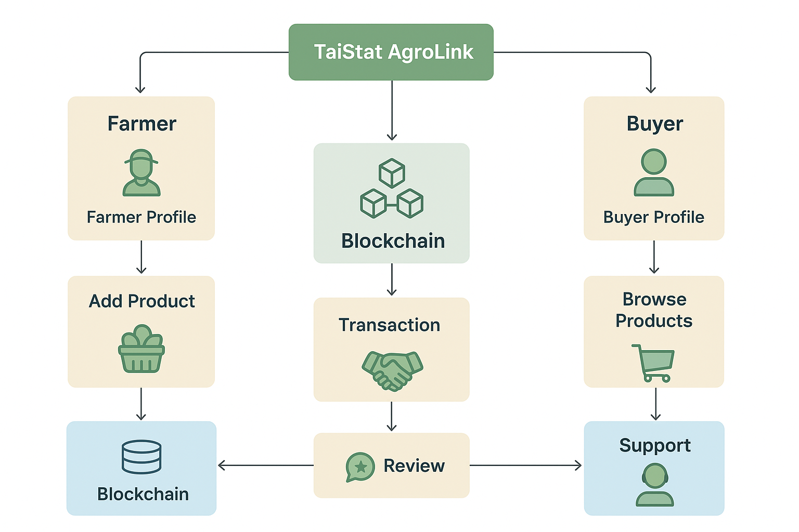
🎯 Goal
A blockchain-powered digital marketplace connecting verified farmers (sellers) and buyers, enabling traceable, secure, and trustworthy agricultural transactions.

1️⃣ USER ONBOARDING FLOW
🧾 Step 1: Registration
- Choose account type → Farmer or Buyer
- Provide:
  - Full Name
  - National ID + Selfie (Verification)
  - Email + Phone
  - County & Town
  - “How did you hear about us?” (Facebook / TikTok / Friend / Other)
- Accept Data Privacy Policy (Kenya Data Protection compliant)
- Verification email/SMS → ✅ Proceed to profile setup

2️⃣ PROFILE SETUP FLOW
👨‍🌾 Farmer Profile
- Personal Info: ID, selfie, phone, location
- Product Info: Photos, fertilizer/pesticide used, growth method
- Traceability (Blockchain): Seed → Harvest data recorded
- Previous Transactions & Scores
- Reviews (from verified buyers)
- Trust Score Badge visible on public profile
🧑‍💼 Buyer Profile
- Personal Info: ID, phone, email, location
- Viewable Purchase History
- Ratings (based on transactions)
- Tenders Created
- Verification Status

3️⃣ DASHBOARD INTERFACE
🌱 Farmer Dashboard
- Analytics: trending commodities, average prices by county, top products
- My Products: upload/manage listings, boost with coins
- Fellow Farmers: network & collaborate
- Bids: view tenders in your category
- Chat: talk to buyers (verified only)
- Wallet: coin balance & renewals
🏪 Buyer Dashboard
- Browse by category: Cereals | Legumes | Poultry | Fruits | Vegetables
- View verified sellers
  - Product photo, price/kg, farmer score, county
- Product details include:
  - Blockchain traceability data
  - Seller rating
  - Fertilizer info & harvest date
- Create Tenders
- View Analytics (average prices per county)
- Chat with sellers (free)

4️⃣ COINS & PREMIUM MODEL
💰 Startup Phase (First 100 sellers & 50 buyers)
✅ Free Access for all users
- Farmers get 100 free coins upon signup
- No subscription for the first month
- Buyers use platform for free always

💸 Post-Launch Monetization (After 100 Sellers & 50 Buyers)
👨‍🌾 For Farmers:
- Monthly Subscription: Ksh 499/month
  - Keeps profile active & visible
  - Allows product uploads + tender bidding
- Coins System:
  - 70 Ksh = 100 coins
  - Tender bid = 200 coins
  - Profile Boost = 500 coins for 7 days
- Auto-renew option available
🧑‍💼 For Buyers:
- Completely free access
- Can create tenders, browse, and chat freely

5️⃣ BLOCKCHAIN TRACEABILITY FLOW
- Every product batch includes:
  - Product ID
  - Farmer ID
  - Dates planted/harvested
  - Fertilizer/Pesticide info
  - Quantity
  - Transaction & review record
- Immutable entry on blockchain → Buyer can “View Verification Chain”

6️⃣ TENDER FLOW
🧾 Buyer:
- Creates tender (commodity, quantity, deadline, county)
- Tender visible only to related farmers
- Tender volume determines visibility priority
👨‍🌾 Farmer:
- Sees tenders in their category
- Click “Bid Now” → AI-assisted bidding template
- Submit bid (200 coins)
- Can team up with others to meet demand
✅ After selection:
- Transaction logged on blockchain
- Rating and review opportunity after completion

7️⃣ CHAT & REVIEW FLOW
💬 Chat:
- Buyer ↔ Farmer communication (encrypted)
- Only verified accounts can message
- Chat visible to Support if dispute arises
⭐ Reviews:
- Only after a verified transaction
- Review factors:
  - Delivery time
  - Quality
  - Accuracy of description
- Updates Trust Score and Visibility Rank

8️⃣ SUPPORT FLOW
- Support Dashboard:
  - Search user by ID (farmer/buyer)
  - See all transactions, chats, and tenders
  - Approve or flag tenders
  - Suspend or block fraudulent accounts
  - Assist in disputes and tender oversight
- Support ensures both sides are protected and verified

9️⃣ SECURITY & COMPLIANCE
- Data encryption (Kenya Data Protection Act)
- Verified ID + Selfie → prevent fake accounts
- Blockchain logging → ensures traceability
- Anti-fraud review algorithm → lower rank for poor trust
- Secure wallet (M-PESA & card payments)
- Periodic re-verification of users

🔁 10️⃣ SYSTEM FLOW SUMMARY
User Registers → Profile Verification (Farmer/Buyer)
↓
Dashboard
├─ Farmer: Upload Products | View Analytics | Join Tenders | Chat
└─ Buyer: Browse Products | Create Tenders | Chat | View Analytics
↓
Transaction → Blockchain Record Created
↓
Review → Update Trust Score & Ranking
↓
Subscription Renewal (Farmers Only)
↓
Support & Verification System

🚀 Optional Future Add-ons
- AI price prediction by region
- Logistics & insurance integration
- Farm input marketplace (fertilizers, seeds)
- Farmer co-operative module for joint tender bidding
- Voice assistant for rural farmers

